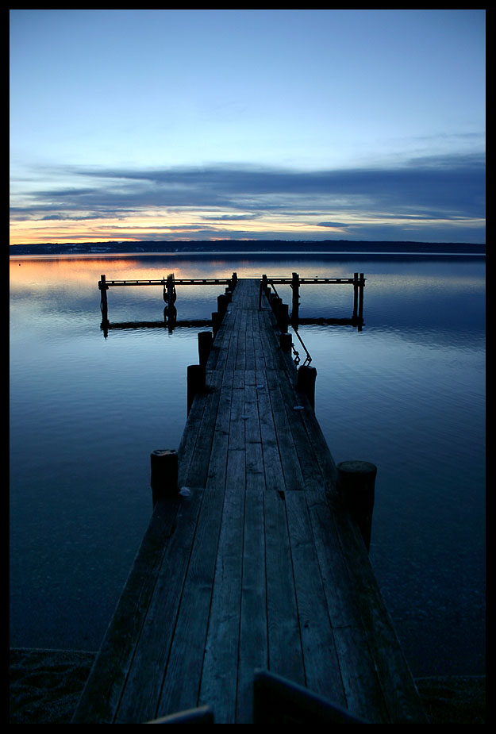
Rasulullaah sulallaahu 'alayhi was sallam, said:

“The first group who will enter Paradise will be like the moon when it is full.
They will not spit or blow their noses or relieve nature.
Their utensils will be of gold and their combs of gold and silver; in their
centers the aloe wood will be used, and their sweat will smell like musk.
Everyone of them will have two wives; the marrow of the bones of the wives'
legs will be seen through the flesh out of excessive beauty. They will neither
have differences nor hatred amongst themselves; their hearts will be as if one heart and they will be glorifying Allaah in the morning and in the evening."

Masjidul Ghurubaa
Laurel, Maryland Presents:

“Come, Let Us Settle Our Differences…”

Date: June 19, 2004
Time: 10:00 A.M – 10:00 P.M.
Location: To Be Announced

Invited Speakers:

Abu Uways Abdullaah Ahmad Ali
Abu Muhammad Taalib Abdullaah
Abu Abdullaah Hasan As-Somaalee

For Lecture Information, Contact “” at …
For Vending, contact “…” at “…”

