Summer School
2008
Boys and girls ages 4 to 10

A New 2 Week Programme
28th July to 8th August
2 weeks of Arts and Craft, Fun Days, Games and Sports.
Also includes a Reading Club, Technology Lessons, Islamic Studies and Qur’aan.

We provide a fun learning environment for your children to spend their summer holidays.

A Fantastic Offer at £60 for 2 Weeks!

Application Forms
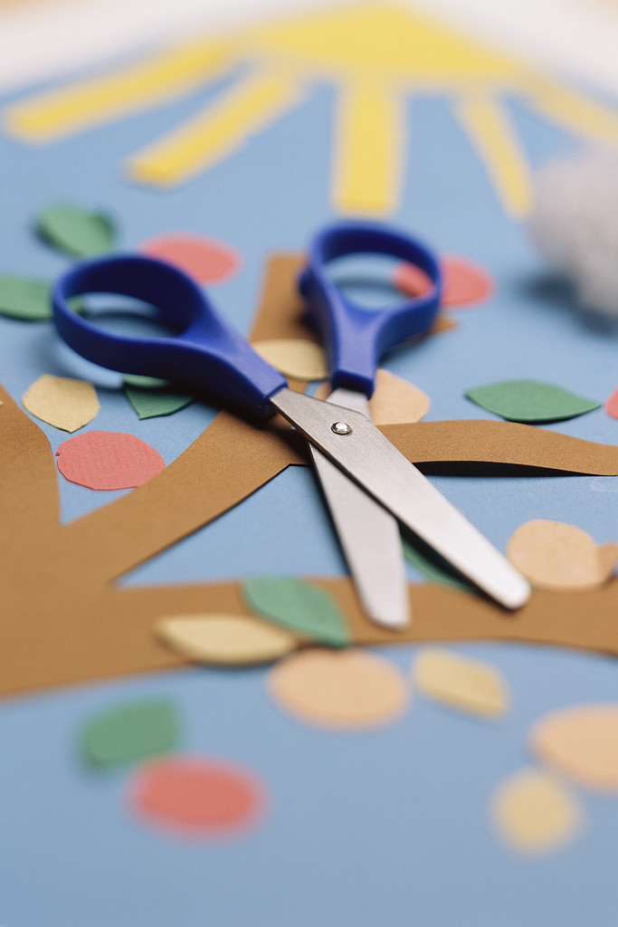
From the Salafi Bookstore, Salafi Independent School

Places will be limited. Early application is advised.
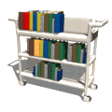
For more information contact the
Salafi Independent School
(0121) 772 4567
e-mail: salafischool@gmail.com

