Summer School
2009
Boys and Girls Ages 4 to 10

A New 2 Week Programme
27th July to 7th August
2 weeks of Arts and Craft, Fun Days, Games and Sports.
Also includes Reading, Technology Lessons, Islamic Studies and Qur’aan.

We provide a fun learning environment for your children to spend their summer holidays.

A Fantastic Offer at £65 for 2 Weeks!

Application Forms
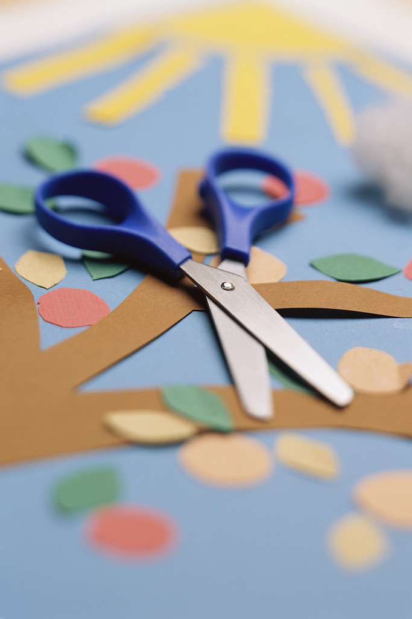
From the Salafi Bookstore, Salafi Independent School

Places will be limited. Early application is advised.
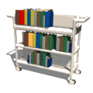
For more information contact the
Salafi Independent School
(0121) 772 4567
E-mail: salafischool@gmail.com

