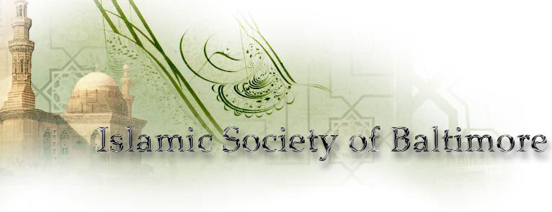

“Sacrificing
for the Hereafter”

Speakers
Shaykh ‘Abdullaah ibn ‘Abdur-Rahmaan Aal Ghudayyan
(Confirmed)

Via Tele-Link from Saudi Arabia

Abul Hasan Maalik al-Akhdar

Via Tele-Link from Saudi Arabia
Abu Uwais Abdullah Ahmed Ali
Abu Abdillah Hassan As-Somali
Taalib Abdullah

For Advance Registration and Vending Info
Brothers: Imam Abdul Mubdee @ 202.276.0166
Ali @ 301.717.8130
Sisters: Umm Layla Khadiyja @ 301.890.8015

$15 per person; $25 per family (one day)
$30 per person; $40 per family (two days)

Lunch/Dinner Available Childcare Available - $5 per child

LOCATION: DC Tunnel Events Center
2135 Queens Chapel Rd. NE
Washington, DC 20018
(go to www.mapquest.com for directions)

Masjid Ahlul Quran wa Hadeeth

Presents

A 2-Day Series of Lectures to Benefit Your Soul
And
Fundraiser for Masjid Ahlul Quran wa Hadeeth

Friday, May 28, 2004 Saturday, May 29, 2004
(Jumuah – 7 pm sharp) (10 am – 5:30 pm) sharp)

