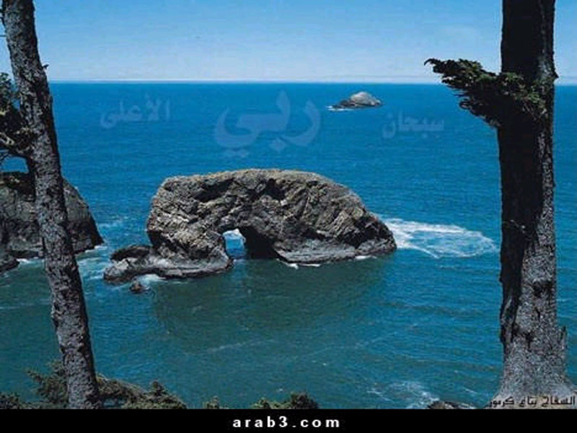

CONFERENCE ADDRESS: 1ST WARD REC CENTER 610 E. 7TH ST
REGRISTRATION FEE: $5.00 PER ADULT, CHILDREN FREE
VENDING: $25.00 SATURDAY & MASJID FEES APPLY FRIDAY

For more information send a reply E-mail or
Call the Masjid @ 704-376-2799
Tele-link w/ Sheikh:

'Ubayd al-Jaabiree

AND OTHER ULAMMA INSHA-ALLAH

Confirmed Speakers are Scheduled

