‘Eid Gathering

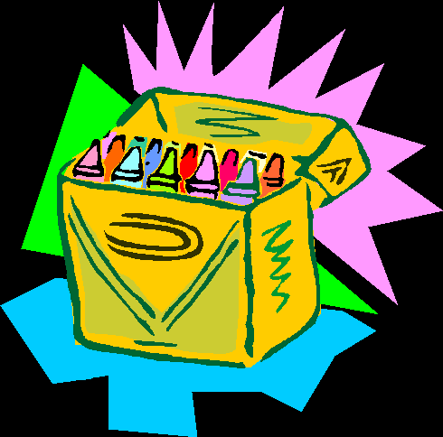

Monday 1st January 2007

1pm to 5.30pm

To city centre

496 Moseley Road
(opp. Swimming Baths)

Balsall Heath

Birmingham B12

All Welcome

Separate Halls for Sisters

Bouncy Castles
Ball Pit,
Gladiators,
Quizzes etc

Stalls available
for vendors

Contact: Abu A’isha Amjad 07875 320823

Abu Hishaam 07878 743889
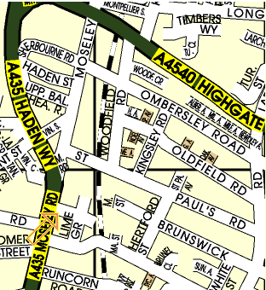

bus no.s 50 & 8

£3.50 Adults
£2.50 Age 5-11
£FREE Under 5’s

ALL PROCEEDS GO TOWARDS
THE SALAFI MASJID & DA’WAH


FREE Activities
A range of stalls for toys
confectionary clothing etc
Freshly prepared food available throughout the day

