
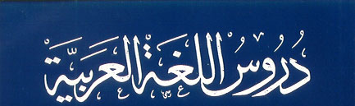
ENTERKEY TRAINING IS OFFERING A 12 WEEK
INTENSIVE ARABIC & TAJWEED EVENING COURSE

THIS IS A RARE OPPORTUNITY TO DEDICATE 12 WEEKS IN STUDYING BOOKS ON ARABIC GRAMMAR, READING, CONVERSATIONAL SKILLS AND QUR’AANIC TAJWEED

Places for brothers and sisters

LESSONS WILL BE HELD EVERY
TUESDAY & THURSDAY FROM 6pm – 9pm
AT
ENTERKEY TRAINING
337-339 COVENTRY ROAD
SMALL HEATH

START DATE IS 27th FEBRUARY
PLACES ARE LIMITED!

For more information or to request a registration form
Please send an email to madinaharabic@hotmail.com
or contact Talha on 07766 240786

12 WEEK INTENSIVE
ARABIC & TAJWEED
COURSE

