صلاة العيد
THE ‘EED PRAYER

عيد الفطر
‘Eedul Fitr 1425 in Daytona Beach

‘Eedul-Fitr Information
Date:
Saturday or Sunday
November 13/14 2004
For exact date visit
www.masjidalghurabaa.uni.cc
Start Time: 9:00 a.m.
Location:
The Dickerson Community Center
308 Martin Luther King Dr. Dayton Beach, FL 32114
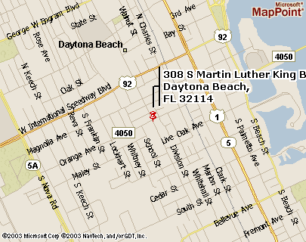
Directions:
From I-95:
Exit onto US-92 E (International Speedway Blvd) Keep Straight on Speedway Blvd. until you reach Nova Rd. Make right onto Nova Rd. At the signal light make left onto Orange Ave. Go down two signal lights. The Dickerson Community Center is at the second signal light on the corner of Martin Luther King Dr. and Orange Ave on the right.
Activities:
Food and Drinks, Games for children, Basketball, Football, Tennis and Racquetball Courts are available

Masjid Al-Ghurabaa in Florida invites you to come and attend ‘Eedul-Fitr with the Salafiyeen of Daytona Beach, Florida. Allah says:
وَاعْتَصِمُواْ بِحَبْلِ اللّهِ جَمِيعًا وَلاَ تَفَرَّقُواْ وَاذْكُرُواْ نِعْمَتَ اللّهِ عَلَيْكُمْ إِذْ كُنتُمْ أَعْدَاء فَأَلَّفَ بَيْنَ قُلُوبِكُمْ فَأَصْبَحْتُم بِنِعْمَتِهِ إِخْوَانًا وَكُنتُمْ عَلَىَ شَفَا حُفْرَةٍ مِّنَ النَّارِ فَأَنقَذَكُم مِّنْهَا كَذَلِكَ يُبَيِّنُ اللّهُ لَكُمْ آيَاتِهِ لَعَلَّكُمْ تَهْتَدُونَ
And hold fast, all of you together, to the Rope of Allâh (i.e. this Qur'ân), and be not divided among yourselves, and remember Allâh's Favour on you, for you were enemies one to another but He joined your hearts together, so that, by His Grace, you became brethren (in Islâmic Faith), and you were on the brink of a pit of Fire, and He saved you from it. Thus Allâh makes His Ayât (proofs, evidences, verses, lessons, signs, revelations, etc.,) clear to you, that you may be guided. (Aali Imran 3:103
The Prophet (sallallaahu ’alayhi wa sallam) said, “I came to you and you had, in Jaahiliyyah two days for play and amusement. Indeed, Allaah has replaced them for you by that which is better than them: The day of an-Nahr (Slaughtering) and the day of al-Fitr (Breaking fast).” Saheeh: Reported by Ahmad (3/103, 178, 235), Aboo Daawood (no. 1134), an- Nisaa‘ee (3/179) and al-Baghawee (no. 1098).

As we know the man is upon the religion of his friend. Therefore we the Salafiyoon should make an attempt to join the salafiyoon in celebrating Eidul-Fitr, and not join the Ahlul Bid’ah wa Ahwah in their gatherings and increase their numbers. Rather as we the salafiyoon of Florida are in need of your support to establish the Dawahtus Salafiyyah in Florida. So brothers and sisters in Daytona Beach and surrounding areas we invite you to attend Salaatul-Fitr with us at The Dickerson Community Center.
For more information visit us at www.masjidalghurabaa.uni.cc

Or contact:

Abdur Rahmaan ibn Pattillo: 1-386-295-9380
Abu Jamaal Shadeed ibn Holmes: 1-386-323-7980
Abu Abdur-Rahmaan Muhammad Abdullah:1-386-405-0027

Masjid Al - Ghurabaa
844 George W. Engram Blvd
Daytona Beach, Florida 32114

